The Structure, Properties and Uses of C₆₀

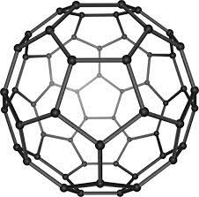 | Description of Buckminsterfullerene (C₆₀)  eg. How many bonds does each C have?  What kind of bonds?  Describe the shape of the structure.  _____________________________  _____________________________  _____________________________  _____________________________  _____________________________  _____________________________

Properties | Reason for this property
Melting point:

Electrical conductivity:

Possible future uses

